Supplemental Food Shelf

Everything You Need to Know…
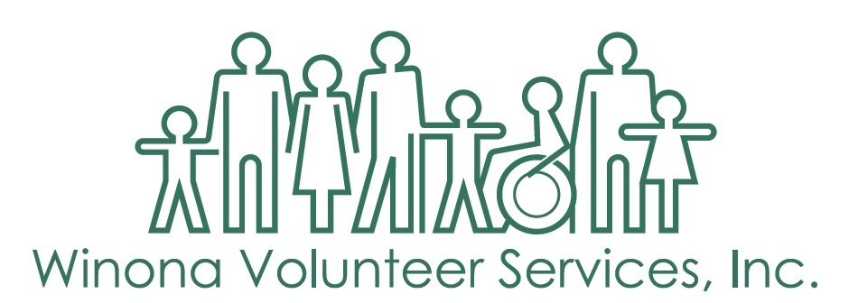

Important Information about the Supplemental Food Shelf (SFS):

Winona Volunteer Services (WVS) would like to make your experience at the Food Shelf a pleasant one. We are a non-profit organization existing on donations of food, money, and volunteer time. We want you to feel comfortable coming here, so if you have suggestions or experience a problem, please ask to speak to the Executive Director or call 452-5591.

We hope that you will appreciate the food that has been donated by the generous residents and businesses of our community and purchased through our area food bank.

The assistance you receive from the food shelf is meant to supplement your food budget. Please understand that the food shelf is not intended to supply all of the food needs of your household.

This handbook is a tool offered to help you understand the Food Shelf guidelines. Our goal is to serve all Food Shelf shoppers fairly and to eliminate any misinformation about the food shelf.

ELIGIBILITY
- People in Winona County can qualify for the Supplemental Food Shelf (SFS)
- Your total household income before taxes must fall under the guidelines provided below:

Income Eligibility: (200% of Federal Poverty Guidelines)
July 1, 2019- June 30, 2020
Family Size | Annual Salary | Monthly Income | Family Size | Annual Salary | Monthly Income
1 | $24,980 | $2,082 | 5 | $60,340 | $5,028
2 | $33,820 | $2,818 | 6 | $69,180 | $5,765
3 | $42,660 | $3,555 | 7 | $78,020 | $6,502
4* | $51,500 | $4,292 | 8 | $86,860 | $7,238
*Add $8,840 to annual income for each additional person

- Each qualifying household is allowed one Food Shelf card.
- If you continue to need the Food Shelf after 12 months, we ask you to renew your card during Food Shelf hours.
- If you lose your card, you can apply for a single-use card in the office each month before shopping. We will issue you a new card after your card expires.

HOW TO USE THE FOOD SHELF

FOOD SHELF HOURS ** listed on the back of your card
Monday 10:00 a.m. – 1:00 p.m.
Tuesday 10:00 a.m. – 1:00 p.m.
Wednesday 10:00 a.m. – 1:00 p.m.
Thursday 3:00 p.m. – 6:00 p.m.
Friday 2:00 p.m. – 5:00 p.m.

- You must show your current Food Shelf card at the door when you enter the food shelf and again at the checkout.
- You can shop once a month only for the current month- and your shopping trip cannot be split into two different days. If you do not shop, you lose that month.
- We urge you to bring reusable shopping bags each time you shop.
- Any household member or friend may shop for you, using your card if you are unable to shop for yourself. They must present your Food Shelf card at the door and checkout.

- To shop, choose the number of items (as shown on your Food Shelf card) and place them in your cart.
# in your household | 1 – 3 | 4 - 5 | 6 & up
Max Total Items: | 30 items | 35 items | 40 items
Max Meat Items (included in total): | 3 | 4 | 4

- An item is any package, can, jar, or bag.
- Some items are limited. Please refer to the list in your cart.
- When you finish choosing your items, approach the check-out line along the back wall and you will be waved forward to the scale.
- At the scale, hand your card to the volunteer. The volunteer will tell you when you can approach the bagging station and choose from available produce, bread, & bakery.
- A $1 donation is suggested at check-out, but not required.
- You will be offered a calendar each time you shop. This is the main way we let you know about upcoming events, classes, closings, and holiday happenings.
- If the Food Shelf must close due to extreme weather conditions or other event, a message will be recorded on our answering machine at 452-5591.

THE FOOD
- The food arrives daily from a variety of sources; there is no ‘best day’ to shop at the Food Shelf. Shop on the day when it works for you to come.
- We make every attempt to discard unusable food items. However, there may be times when we miss an item. If you notice something, please call our attention to it. Remember, you are taking food freely at your own risk and the Winona Volunteer Services Food Shelf cannot be held responsible for these donations.
- Foods are dated in many ways. Call the manufacturer’s number on the package if you need information.
- Product will last past the “Sell By” date under proper storage conditions in your home refrigerator or freezer.

WHAT WE ASK OF YOU
- The Food Shelf is staffed by volunteers. Please be considerate of their time and arrive at least 30 minutes before the scheduled closing time. This way you will have enough time to shop.
- If all carts are being used when you arrive, you will be asked to wait outside until a cart is available.
- Please exit our parking lot through the alley onto Chestnut Street, not by backing onto 2nd Street.
- Dogs are not allowed in the food shelf unless you have talked with office staff first.
PLEASE BE CONSIDERATE…
- Make sure your children remain with you at all times. Any accident your child has caused to another person or Winona Volunteer Services property is your responsibility.
- All food you receive from the Food Shelf is intended for your household only.
- It is our intent to provide services to all of our clients in an atmosphere of respect and cooperation. In order to do this, we will refuse to serve anyone who displays the following: -Physically or verbally aggressive behavior - Argumentative behavior - Use of profanity - Refusing to leave when asked -Unwilling to abide by Food Shelf policies -Under the influence of alcohol or illegal drugs
- For everyone's protection, video cameras are installed in the Food Shelf, Clothes Shop, waiting room, and the exterior of the buildings.

OTHER ASSISTANCE
- If you have run out of food, money, & you’ve shopped in the Food Shelf for the month, you can ask for emergency food in the office.
- If you need other types of help, please come to the office. We will do our best to connect you with additional services.
- We distribute Nutrition Assistance Program for Seniors (NAPS) food boxes to qualifying individuals on the first Wednesday of the month between 2:00 – 4:00pm. To qualify for NAPS, please come to the office and ask for more information.
- If someone age 60 years or older is listed as part of your household, you may shop on the 1st Wednesday of the month between 2 pm & 4 pm during Senior Day. Persons with disabilities are also invited to shop that day.
- Community representatives may approach you inside the Food Shelf with resource information.

NUTRITION
- You can talk with our nutrition educator about planning meals with food shelf items, budgeting for food, creating a healthier diet or any food-related or special diet questions you may have. You can also get hands-on training in our kitchen to build your cooking skills and get specific recipes.
- Call for an appointment for any of these services.

COMPLAINT PROCESS
If at home you feel you have a faulty product from the Food Shelf, here’s what to do:
- If you have not already consumed the product, please do not do so.
- Call Winona Volunteer Services @ 507-452-5591 to report the defect.
- Please return the product to Winona Volunteer Services in its original packaging.
NON-DISCRIMINATION STATEMENT
In accordance with the Minnesota Human Rights Act and the USDA Civil Rights Regulations, Winona Volunteer Services Supplemental Food Shelf does not and will not discriminate on the basis of race, color, creed, national origin, sex, religion, age, sexual orientation, gender expression, marital status, or status with regard to public assistance, disability or political belief.
If you feel you have been discriminated against, please ask for our grievance procedure by contacting the Executive Director at 507-452-5591.
TOBACCO-FREE
The Winona Volunteer Services properties will be tobacco-free. Thank you for not using any form of tobacco or electronic cigarettes on the WVS properties.
www.winonavs.org
507-452-5591

